

Guidelines for owner completion of the Emergency Action Plan, or EAP, Template

- Replace all highlighted text (including MAGENTA and GREEN with appropriate names, descriptions, or phone numbers.

- State Emergency Management Agency area letters for all counties in the state are available at http://sema.dps.mo.gov/sacp.htm

- Assistance is available from your local Emergency Management Director for the items in the template designated in GREEN. A list of Emergency Management Directors is available at

http://www.sema.dps.mo.gov/All%20EMDs%20Feb%2010%20website.pdf

- Appendix A, inundation maps will be provided by the department when they become available. However all other portions of the Emergency Action Plan can be completed prior to the addition of the inundation map.

- Owners can begin completing the Residents/Businesses/Entities/Infrastructure at Risk table using their best judgment and updating the list when an inundation map becomes available.

- The Water Resources Center Dam and Reservoir Safety Program will assist in completing Appendix B highlighted in YELLOW. Please contact the department at 573-368-2175.

- When completed, a minimum of three copies are required. See appendix E for the required record holders.

For questions concerning the EAP process contact:

Missouri Dept. of Natural Resources

Dam and Reservoir Safety Program

Phone: 573-368-2175

Other sources of information:

www.damsafetyaction.org

Emergency Action Plan, or EAP

Dam Name

National Inventory of Dams, or NID, MO#####

County Name County, Missouri

SEMA Area X
Reviewed and Updated:
Insert date 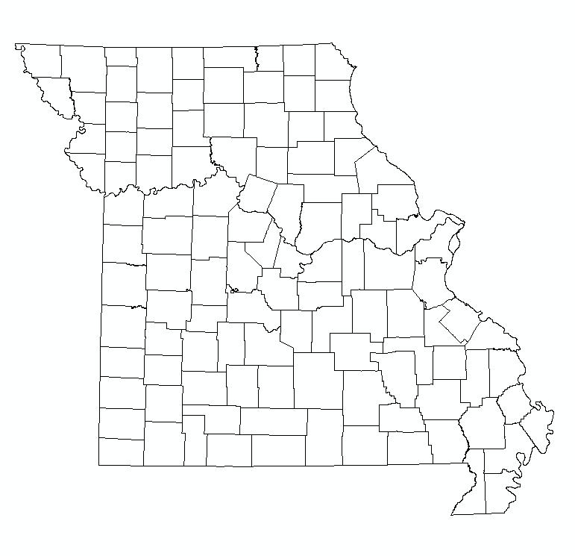

Insert map here or draw map showing neighboring towns, major roads and location of your dam. Color in your county on the Missouri map to the left
Insert Name Here Insert Name Here
Name of dam owner/operator Name of county Emergency Management Director
Name of County, Missouri

___________________ __________________
Date Date

Basic EAP Data

Purpose
The purpose of this EAP is to reduce the risk to human life and minimize property damage during an unusual or emergency event at Dam Name.

Notification Procedure

This EAP provides general guidance for recognizing and characterizing an emergency situation occurring at the dam. The dam owner should act quickly to evaluate the emergency situation and then follow the notification procedures according to the corresponding level of emergency.

Potential Impacted Area
See Inundation Map (Appendix A) and Residents/Businesses/Entities at Risk table for the locations and contact information of the following residents and businesses that may be flooded if the dam should fail This list may also include critical infrastructure such as pipelines, power plants, substations, or sewer plants.
(Describe homes, businesses, and roads in the downstream evacuation area)

Directions to dam (Review Arrival Time Map that shows major roads to the dam)
(Insert detailed driving directions to get to dam (from the main emergency response location For dams not visible from public roads describe the access route to the dam from the nearest public road.)

Guidance for Determining the Emergency Level
This information should be used as a general guide for recognizing and characterizing the type of emergency situation occurring at the dam. The dam owner should notify the appropriate emergency contacts based upon the emergency level assigned to each situation.

Level 1 Emergency - Nonemergency, unusual event, slow to develop
- Reservoir water surface elevation at emergency spillway crest or spillway is flowing with no active erosion.
- New seepage areas in or near the dam.
- New cracks in the embankment greater than ¼-inch wide without seepage.
- Visual movement/slippage of the embankment slope.
- Instrumentation readings beyond predetermined values.
- Measurable earthquake felt or reported on or within 50 miles of the dam.
- Damage (vandalism/sabotage) to dam or appurtenances with no impacts to the functioning of the dam.
- Modification (vandalism/sabotage) to the dam or appurtenances that could adversely impact the functioning of the dam.

Level 2 Emergency - Potential dam failure situation, rapidly developing
- Spillway flowing with active gully erosion.
- Spillway flow that could result in flooding of people downstream, if the reservoir level continues to rise.
- Reservoir level is 1 foot below the top of the dam.
- New seepage areas with cloudy discharge or increasing flow rate.
- Observation of new sinkhole in reservoir area, on embankment or downstream of dam.
- Cracks in the embankment with seepage.
- Earthquake resulting in visible damage to the dam or appurtenances.
- Verified bomb threat that, if carried out, could result in damage to the dam.
- Damage to dam (vandalism/sabotage) or appurtenances that has resulted in seepage flow.

Level 3 Emergency - Urgent; dam failure imminent or is in progress
- Spillway flowing with an advancing headcut that is threatening the control section.
- Spillway flow that is flooding people downstream.
- Water from the reservoir is flowing over the top of the dam (not just auxiliary/emergency spillway).
- Seepage that is obviously eroding soil from within the embankment or rapidly increasing in flow rate.
- Rapidly enlarging sinkhole.
- Sudden or rapidly progressing slides of the embankment slopes.
- Earthquake resulting in uncontrolled release of water from the dam.
- Detonated bomb that has resulted in damage to the dam or appurtenances.
- Damage to dam (vandalism/sabotage) or appurtenances that has resulted in uncontrolled water release.

Emergency Level 1 Notifications
Nonemergency, unusual event; slowly developing.
Note:
1., 2., etc., denotes call sequence

Legend:
Calls by operator/owner ______
Second level calls - - - - -
See Emergency Services Contacts sheet for contact
information about back-ups to the persons shown above
and other emergency personnel.
Dam Operator’s
Technical Reps. (if applicable)
Owner’s engineer
Name of engineer
XXX-XXX-XXXX (Office)
XXX–XXX–XXXX (Home)
XXX–XXX–XXXX (Cell)
State Dam Safety Official
Missouri
Water Resources Center
Robert Clay
573-368-2175 (Office)
573-341-5761 (Home)
573-368-6191 (Cell)
(1.)
(2.)
Dam Operator or Owner
Name of Dam Owner
XXX-XXX-XXXX (Office)
XXX-XXX-XXXX (Home)
XXX-XXX-XXXX (Cell)
Emergency Level 2 Notifications
Emergency event, potential dam failure situation; rapidly developing.

Dam Owner/Operator

Name of Dam Owner
XXX-XXX-XXXX (Office)
XXX-XXX-XXXX (Home)
XXX-XXX-XXXX (Cell)
Local Emergency Management Dispatcher
Name of County County Amateur
Radio Association:
Name of association rep (optional)
XXX-XXX-XXXX
National Weather Service
XXX-XXX-XXXX
Missouri Highway Patrol Dispatcher
Local Law Enforcement/Fire Protection Agency Dispatcher
911
County Emergency Director/Sheriff
Name of director/sheriff
XXX-XXX-XXXX (Office)
XXX-XXX-XXXX (Home)
XXX-XXX-XXXX (Cell)
Dam Operator’s
Engineer
Name of engineer
XXX-XXX-XXXX (Office)
XXX-XXX-XXXX (Home)
XXX-XXX-XXXX (Cell)
State Dam Safety Official
Missouri
Water Resources Center
Robert Clay
573-368-2175 (Office)
573-341-5761 (Home)
573-368-6191 (Cell)
(1.)
(2.)
(3.)
Note:
1., 2., etc., denotes call sequence

Legend:
Calls by operator/owner ______
Second level calls - - - - -
See Emergency Services Contacts sheet for contact
information about back-ups to the persons shown above
and other emergency personnel.
Emergency Level 3 Notifications
Urgent event, dam failure appears imminent or is in progress.
Dam Operator’s
Engineer
Name of engineer
XXX-XXX-XXXX (Office)
XXX-XXX-XXXX (Home)
XXX-XXX-XXXX (Cell)

Missouri Highway Patrol Dispatcher

Local Law Enforcement/Fire Protection Agency Dispatcher

National Weather Service
XXX-XXX-XXXX

Local Emergency Management Dispatcher

Dam Owner/Operator
Insert Name Here

XXX-XXX-XXXX (Office)
XXX-XXX-XXXX (Home)
XXX-XXX-XXXX (Cell)

State Dam Safety Official
Missouri
Water Resources Center
Robert Clay
573-368-2175 (Office)
573-341-5761 (Home)
573-368-6191 (Cell)

Name of County County Amateur
Radio Association:
Name of association rep
XXX-XXX-XXXX

(1.)
(2.)
(3.)
911
County Emergency Director/sheriff
Name of director/sheriff
XXX-XXX-XXXX (Office)
XXX-XXX-XXXX (Home)
XXX-XXX-XXXX (Cell)
Note:
1., 2., etc., denotes call sequence

Legend:
Calls by operator/owner ______
Second level calls - - - - -
See Emergency Services Contacts sheet for contact
information for back-ups to the persons shown above
and other emergency personnel.
Emergency Services Contacts
Agency / Organization | Principal Contact | Address | Office Phone No. with Area Code | Alternate Telephone Numbers
XXXX County Sheriff | Sheriff’s Name | Contact Address | XXX-XXX-XXXX | XXX-XXX-XXXX (H)  XXX-XXX-XXXX (C)
Owner/Representative of Name of Dam | Name of owner | Contact Address | XXX-XXX-XXXX | XXX-XXX-XXXX (H)  XXX-XXX-XXXX (C)
County Emergency Management Director | Name of Director | Contact Address | XXX-XXX-XXXX | XXX-XXX-XXXX (H)  XXX-XXX-XXXX (C)
Local Fire Department | Contact Name | Contact Address | XXX-XXX-XXXX
Local Police | Contact Name | Contact Address | XXX-XXX-XXXX
Local Highway Patrol | Contact Name | Contact Address | XXX-XXX-XXXX
Name of county County  Road Department | Contact Name, Supervisor | Contact Address | XXX-XXX-XXXX | XXX-XXX-XXXX (H)  XXX-XXX-XXXX (C)
Water Resources Center  Dam and Reservoir Safety Program | Robert Clay  Chief Engineer | 111 Fairgrounds Rd.  Rolla, MO 65401 | 573-368-2175 | 573-341-5761 (H)  573-368-6191 (C)
Department of Natural Resources Emergency Response | Duty Officer  EER | P.O. Box 176  Jefferson City, MO  65102 | 24 HOUR NO: 573-634-2436 | 573-526-3380  (Brian Allen, Chief, EER)
SEMA Duty Officer |  |  | 573-751-2748
National Weather Service | Jim Kramper | St. Charles, MO | 636-447-1876 | 1-800-852-7497  636-447-1769 (Fax)
National Weather Service | Andy Bailey | Kansas City, MO | 816-540-5417
National Weather Service | Steve Runnels | Springfield, MO | 417-863-1456
National Weather Service | Ricky Shanklin | Paducah, KY | 270-744-6440
Missouri Department of Transportation | Emergency Operation Center 24-hour cell no. |  | 573-522-9503
Missouri Department of Transportation | County Shed |  | XXX-XXX-XXXX | XXX-XXX-XXXX
Natural Resources Conservation Service  (For NRCS Dams) | Dick Purcell  State Engineer | 601 Bus. Loop 70 W.Columbia, MO 65203 | 573-876-0910 | XXX-XXX-XXXX (H)  XXX-XXX-XXXX (C)
Local TV Station | Contact Name | Contact Address | XXX-XXX-XXXX | XXX-XXX-XXXX
Local Radio Station XXXX AM or FM | Contact Name | Contact Address | XXX-XXX-XXXX

Residents/Businesses/Entities/Infrastructure at Risk
Brief summary of number of entities within inundation zone.
Entity No. | Resident/business  or other impacted entity | Address | Phone No. with area code | Distance downstream from dam  (mi)
X | Name of entity | Address/location of entity | XXX-XXX-XXXX | Distance from dam
X | Name of entity | Address/location of entity | XXX | Distance from dam
X | Name of entity | Address/location of entity | XXX | Distance from dam
X | Name of entity | Address/location of entity | XXX | Distance from dam
X | Name of entity | Address/location of entity | XXX | Distance from dam
X | Name of entity | Address/location of entity | XXX | Distance from dam
X | Name of entity | Address/location of entity | XXX | Distance from dam
X | Name of entity | Address/location of entity | XXX | Distance from dam
(Use additional sheets if necessary)

Resources Available
Locally available resources include: (if not available please note)
Heavy Equipment Service  and Rental | Sand and Gravel Supply | Ready-mix Concrete Supply
Name:  Address:  Phone number with area code: | Name:  Address:  Phone number with area code: | Name:  Address:  Phone number with area code:
Pumps | Diving Service | Sand Bags
Name:  Address:  Phone number with area code: | Name:  Address:  Phone number with area code: | Name:  Address:  Phone number with area code:

Appendix A

Inundation Study

Inundation Map vs. Evacuation Area

Inundation maps have been developed from best available information using reasonable assumptions and standardized methods. They are approximations of the maximum water surface extents resulting from a complete dam breach and draining of the full reservoir. Inundation maps are empirical hydrologic and hydraulic simulations that can only be field verified in the event of an actual breach.

Evacuation areas and call lists should take into consideration the anticipated local impacts of flooding; knowledge of local infrastructure, both occupancy and ownership; and potentially interrupted services or cut-off access, which would be caused by dam failure. Depending upon actual circumstances, appropriate alert and evacuation areas could be more or less extensive than the simulated inundation zones.

Insert inundation map here. It is suggested this section be denoted by a tabbed divider to allow quick access to the inundation map during an emergency.

Appendix B
National Inventory of Dams (NID) Data

Dam name:
State: Missouri
NID ID: MOxxxxx
Sec: Township: Range:
Longitude: decimal degree
Latitude: decimal degree
Longitude: º ’ ”
Latitude: º ’ ”
County:
Stream:
Nearest town downstream:
Distance to nearest town:
Year constructed:
Nearest town:

Type of dam: (indicate only one)
earthfill rock fill concrete tailings
Max. discharge: ft.³/s
Max. storage: acre-ft.
Normal storage: acre-ft.
Surface area: acres
Drainage area: acres
Inspection frequency: yrs.
State regulatory agency:
Missouri DNR WRC DRSP
Dam height: ft.
Dam length: ft.
Current hazard class:
Principal spillway type:
Emergency spillway type:

Comments: __________________________________________________________________________
__________________________________________________________________________
__________________________________________________________________________
___________________________________________________________________________

Appendix C

Unusual or Emergency Event Log
(To be completed during the emergency)
Dam name: County:
When and how was the event detected?

Weather conditions:

General description of the emergency situation:

Emergency level determination: Made by:

Actions and Event Progression
Date | Time | Action/event progression | Recorded by

Appendix D

Glossary

Abutment The part of the valley side against which the dam is constructed. The left and right abutments of dams are defined with the observer looking downstream from the dam.

Appurtenances Structures incident to or annexed to dams essential to the proper operation, maintenance or functioning of the dam. This includes such structures as spillways, low level outlet works and water conduits, such as tunnels, pipelines or penstocks, either through a dam or its abutments.

Breach An opening through the dam that allows draining of the reservoir. A controlled breach is an intentionally constructed opening. An uncontrolled breach is an unintended failure of the dam.

Control section An usually level segment in the profile of an open channel spillway above which water in the reservoir discharges through the spillway.

Dam An artificial barrier generally constructed across a watercourse for the purpose of impounding or diverting water.

Emergency The appurtenant structure that provides the controlled conveyance of excess
spillway water through, over, or around the dam.

Instrumentation An arrangement of devices installed into or near dams that provide measurements to evaluate the structural behavior and other performance parameters of the dam and spillway structures. Examples include seepage measuring weirs, piezometers, inclinometers and survey monuments.

Low level outlet An appurtenant structure, usually consisting of a pipe through the embankment or

works principal spillway structure equipped with a valve, whose purpose is to allow lowering the lake level.

Principal The appurtenant structure that conveys normal inflow through or around the

spillway embankment.

Reservoir The body of water impounded or potentially impounded by the dam.
Seepage The natural movement of water through the embankment, foundation, or abutment of the dam.

Appendix E

Record of Holders of Control Copies of this EAP
Copy Number | Organization | Person receiving copy | E-mail Address
1 | Owner’s name and address | Owner’s Name | Owner’s E-mail
2 | Local Emergency Management  contact and address | Contact Name | Contact E-mail
3 | Missouri Department of Natural Resources Dam Safety Program and address | Bob Clay | bob.clay@dnr.mo.gov

Record of Revisions and Updates Made to EAP
Revision Number | Date | Revisions made | By whom
1 | Date | Describe revision to EAP | Name

